Dis-Asia-Indus-Venus-Bird Beak-3000 BCE

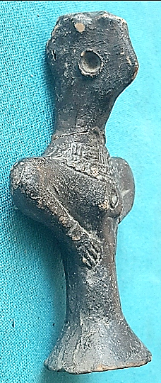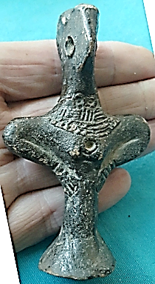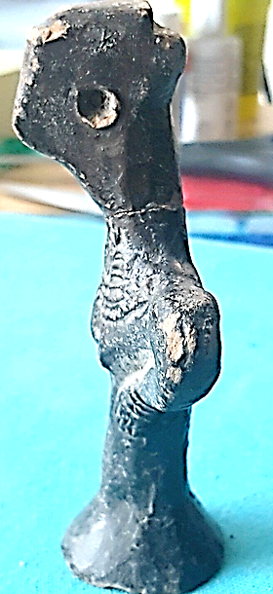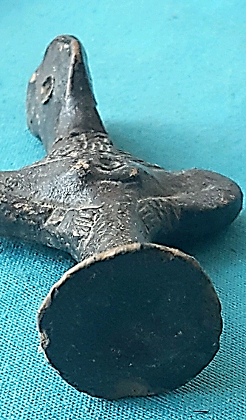

Estimated delivery **Friday, Jan 13, 2017** **- Thursday, Jan 19, 2017**

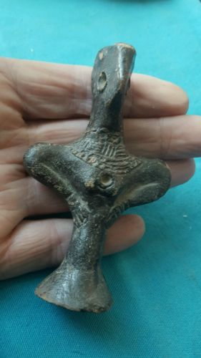

[**RARE ANCIENT INDUS VALLEY FERTILITY IDOL FROM THE HARAPPA CULTURE 3300-1200 BC**](http://www.ebay.com/itm/162342760032)

|  |  |
| --- | --- |
| Item price | $99.35 |
| Quantity | 1 |
| Item number | 162342760032 |
| Shipping service | International Tracked Postage |

Estimated delivery **Friday, Jan 13, 2017** **- Thursday, Jan 19, 2017**



[**RARE ANCIENT INDUS VALLEY FERTILITY IDOL FROM THE HARAPPA CULTURE 3300-1200 BC**](http://www.ebay.com/itm/162342760032)

|  |  |
| --- | --- |
| Item price | $99.35 |
| Quantity | 1 |
| Item number | 162342760032 |
| Shipping service | International Tracked Postage |